Healthcare in prison

Unit 2
Talking about my health



English to help you understand how to get help when you are ill in prison

Contents

Workbook learning goals | Page 3
Workbook 2 – Health problems: Task 1 | Page 4
Workbook 2 – Health problems: Task 2 | Page 6
Workbook 2 – Health problems: Task 3 | Page 8
Workbook 2 – Health problems: Task 4 | Page 9
Workbook 2 – Health problems: Task 5 | Page 11
End of Workbook check | Page 13
Workbook 2 Answer key | Page 14

People get ill in prison just like they do outside prison. This means you will probably need to see a doctor or someone in healthcare.

Learn some words to talk about how you feel.

Learning goals

By the end of this unit you will be able to:

- use words to describe how you are feeling
- learn the names of some illnesses
- understand questions a healthcare worker will ask you

Task 1 – Health problems

- Who has a health problem?
Here are two men, Pete and Francis. Tick () who is ill or has a health problem.
 | 
Pete | Francis

- Name the problem (or symptom)
Pete has toothache. It hurts! Write the words from the box under the correct picture on the next page.

a runny nose asthma toothache earache a sore throat
a headache a bruise backache chest pain
a swollen ankle a cough a high temperature

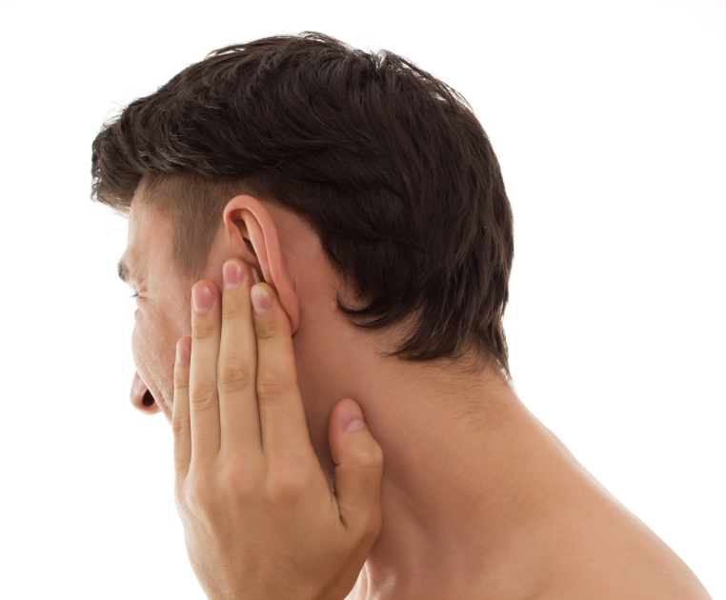 | 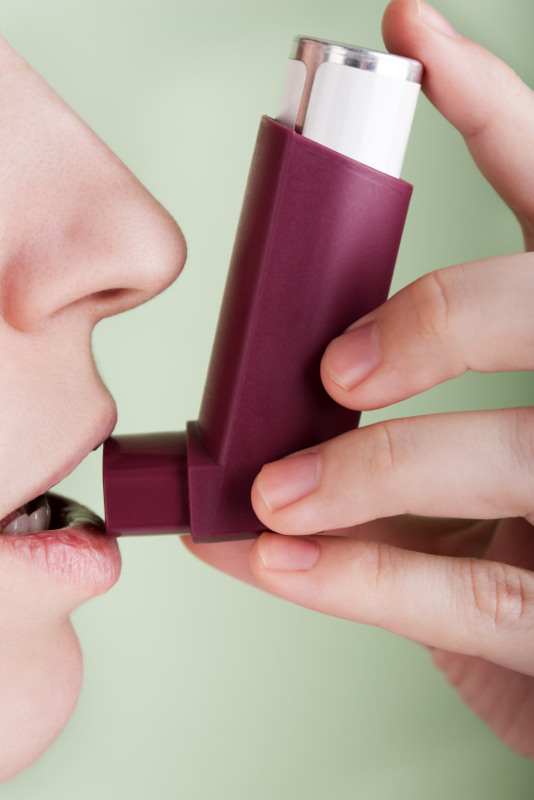 | 
1. | 2. | 3. toothache
 |  | 
4. | 5. | 6.
 |  | 
7. | 8. | 9.
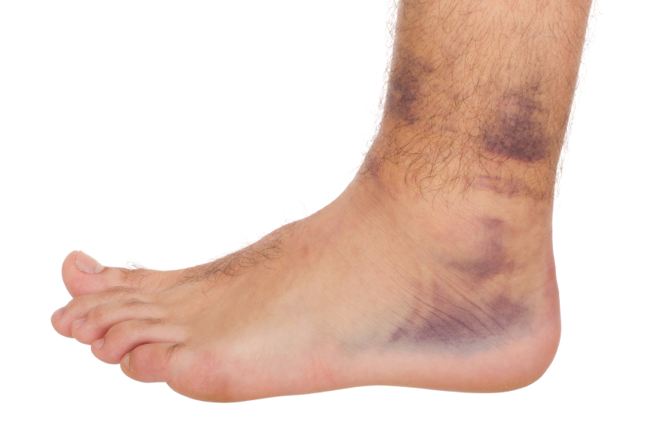 |  | 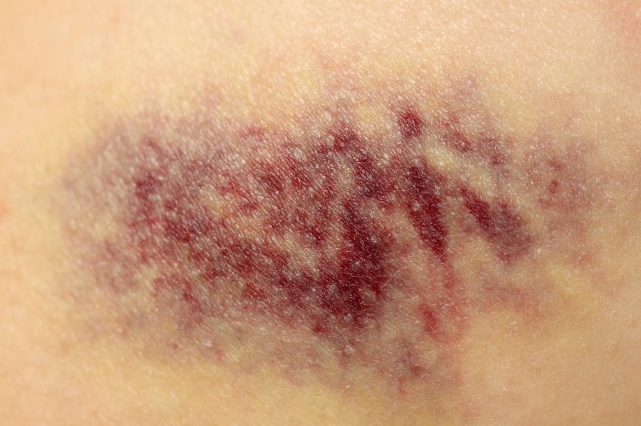
10. | 11. | 12.

Task 2 Read a conversation: speaking to a PID (PID =Prisoner Information Desk)

Man: Hello. I feel ill. Could I see a doctor please?
PID worker: What’s the matter?
Man: I’ve got a bad headache and a sore throat. I want to rest in cell.
PID worker: Have you filled in an app or an application?
Man: No, I haven’t. I asked the officer for an app... and he told me to speak to you.
PID worker: OK that’s fine. Fill it in now and then put it in the medical box. Write something here too about how you feel.
Man: When can I see a doctor?
PID worker: It depends. If you fill in an app, you will see a doctor as soon as possible.
Man: Thanks for your help.
PID worker: No problem, mate.

Read the conversation and answer the questions. Tick () the answers.

- What’s wrong with the man?
He’s got toothache
He’s depressed.
He has a headache and sore throat.

- How can the man get an appointment with a doctor?
Fill in a form called an app.
Ring the doctor.

- When can the man see a doctor?
Tomorrow.
They don’t know.
Grammar: have got / has got

He’s got a headache and a sore throat.

- Write the words into the table.

they’ve I’ve he’s we’ve she’s you’ve

I have  = I’ve | got | a | headache.
you have  = | got | a | sore throat.
he has  = | got | - | earache.
she has  = | got | - | asthma.
we have  = | got | a | cough.
they have  = | got | a | nosebleed.

Grammar: word order

got / a / headache / have / I
I have got a headache.

He / asthma / got / has
- _________________________

nosebleed / got / I / ‘ve / a
- _________________________

You / a / cough / ‘ve / got
- _________________________

Task 3 – Saying how you feel

What’s he saying to the doctor?

- 
I’ve got backache.

- 
I’ve got __ ______ _______.

- 
I’ve got a __________ on my arm.

_______ _______ __________.

- 

- 

Task 4 – Questions and illnesses


Before you start:
Look at these sentences:
These are painkillers or tablets.

Many people have allergies. Some people are allergic to milk, nuts or bread.



I’m allergic to nuts. I can’t eat them. They make me ill.

Do you have any allergies? _________________________________________

Here are some questions a healthcare professional might ask you. Match the question with the answer.

- What’s the matter? a. Yes, I took some painkillers.
- Where does it hurt? b. Yes, I do. I’m allergic to milk.
- Have you got a temperature? c. I feel sick.
- Have you taken anything? d. Since Monday.
- Do you have any allergies? e. No, I don’t think I have.
- How long have you felt sick? f. In my neck.
Task 4b – These men don’t feel very well. What’s wrong?

I feel down
all the time.
I can’t see very well.


4
2
1
3
Match the sentence with the illness.

- I feel down all the time. diabetes
- I can’t see very well. depression
- I feel really weak. I need some sugar. asthma
- I can’t breathe. a cold
- I’ve got a sore throat and runny nose. eye problems

Task 5: Health wordsearch

Find these words in the puzzle:

bruise cold cough depression
earache flu pain sick
sore symptoms swollen toothache

s | y | m | p | t | o | m | s
w | d | a | t | o | r | o | o
o | e | z | c | o | l | d | r
l | p | b | y | t | a | q | e
l | r | t | o | h | z | t | i
e | e | i | p | a | i | n | b
n | s | q | b | c | t | y | u
y | s | e | u | h | u | r | t
d | i | a | b | e | t | e | s
s | o | r | w | y | o | r | z
a | n | a | z | b | c | p | b
s | i | c | k | o | o | a | r
b | j | h | i | t | u | u | u
t | r | e | a | t | g | i | i
u | x | b | k | o | h | r | s
f | l | u | r | y | i | y | e

Word list – new words about my health. Add any more new words you have learnt in the spaces at the bottom.

Write the word in your language.
 |  | symptom | translation
I’ve got | a | headache
 | - | backache
 | - | earache
 | - | stomach ache
 | - | toothache
 | - | chest pain
 | - | diarrhoea
 | a | bruise
 | a | blister
 | a | cough
 | a | runny nose
 | a | swollen ankle
 | a | sore throat
 | a | temperature
 | a | nosebleed

End of unit check

Now you have finished this unit, how do you feel? Tick () the box that is true for you.

 | Yes | A little | No
I can use words to describe how I am feeling.
I can say the names of some illnesses.
I can understand questions a healthcare worker will ask me

Answer key: Workbook 2 – Talking about your health ()

Task 1
- Pete
1.2
- earache
- asthma
- a runny nose
- a sore throat
- toothache
- chest pain
- backache
- a swollen ankle
- a headache
- a cough
- a bruise
- a high temperature

Task 2
- He has a headache and sore throat.
- Fill in a form called an app.
- They don’t know.
- you’ve, he’s, she’s, we’ve, they’ve
- He has got asthma.
- I’ve got a nosebleed.
- You’ve got a cough.

Task 3
- I’ve got backache.
- I’ve got a sore throat.
- I’ve got a bruise.
- I’ve got a toothache.
- I’ve got a swollen ankle.

Task 4
- c
- f
- e
- a
- b
- d

Task 4b
- depression
- eye problems
- diabetes
- asthma
- a cold

Task 5
s | y | m | p | t | o | m | s
w | d | a | t | o | r | o | o
o | e | z | c | o | l | d | r
l | p | b | y | t | a | q | e
l | r | t | o | h | z | t | i
e | e | i | p | a | i | n | b
n | s | q | b | c | t | y | u
y | s | e | u | h | u | r | t
d | i | a | b | e | t | e | s
s | o | r | w | y | o | r | z
a | n | a | z | b | c | p | b
s | i | c | k | o | o | a | r
b | j | h | i | t | u | u | u
t | r | e | a | t | g | i | i
u | x | b | k | o | h | r | s
f | l | u | r | y | i | y | e

